Logbook 03/08/2026
- Ran the Harmony RNA script with the integration specifics (treatment, orig.ident, tech, experiment), tech indicates the difference between all groups and CITEseq-Toxo, which was a 3’ experiment I think, while the rest were 5’ (or the other way around)
- Made the WNN from the protein and RNA Harmony integrations
- Ran scib on the integrations (scVI, totalVI, harmony) after converting the .rds objects to AnndataR
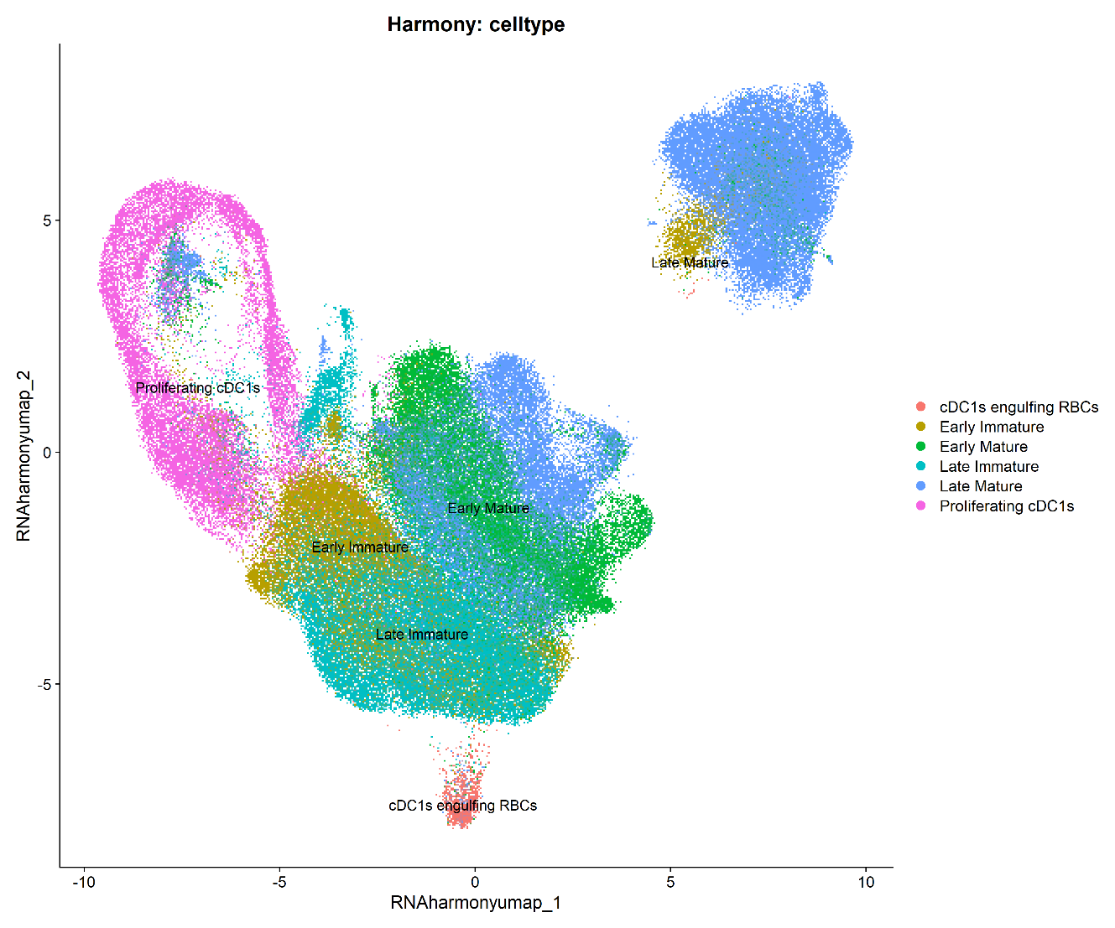
This is the figure of the Harmony RNA integration, which went quite good, except for maybe the top right, which split off. The other cells in the “Late Mature” cluster are kind of worrying, so I made some plots of them to show if this is a wrong annotation, or a problem with the integration.
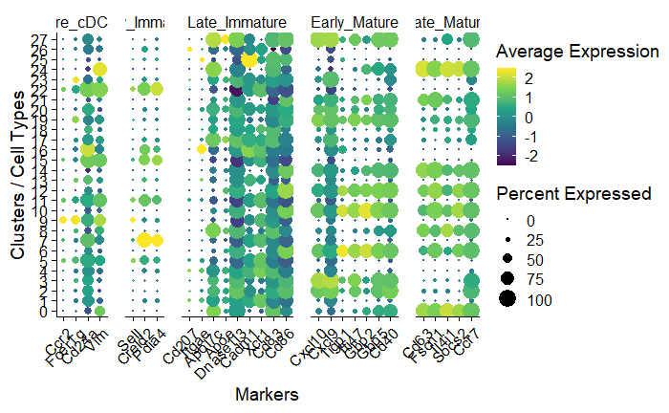
Specific plots for the Late_Mature and Early_Immature subsets:
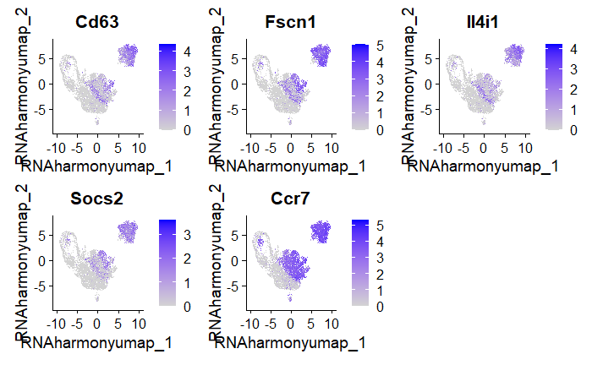
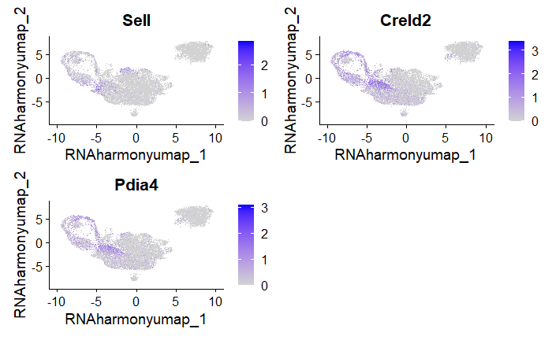
So clearly, the separate Early_Immature subset near the Late Mature cluster is a false annotation. Except (see pdf), there is another problem, some EM markers show too much in the LM cluster, and the opposite way around.
Instead of wildly guessing integration parameters, we can also calculate which metadata drives variance using PCs or Variance partitioning

- Did WNN on the Harmony integrations
- Ran scib-metrics (not optimized I think, probably some mistakes with the layer conversions)
- Samuels’ rds file did not contain the Harmony space anymore, only the UMAP from the Harmony integration. It is probably still present in the 56 Gb file, but I have not opened that yet.

TODO:
- Scib benchmark of the integrations, which needs AnndataR conversion first
- Then use the best integration, maybe try to improve it and then start downstream analysis of the dataset (annotation, pseudobulk DE, GSEA, composition analysis, differences between treatments, GRN

